**Confidential Memo**

TO: Roberto Berardi

FROM: Gabe Cayton

CC: Timothy Woody

SUBJECT: Advice and Counsel on EU Design

DATE: 10/14/18

**Intro:**

The Intent of this memorandum is to address the concerns that EU Design (EU) is encountering. As the business continues to grow, and the market that it serves continues to grow and change along with it, EU would benefit from structured organizational changes that would be intended to alleviate employee workload, organizational communication lapses and allow for the company to be more responsive to the changes that constantly take place in the fashion industry.

**Analysis:**

EU is currently in a transitional phase, and due to its stellar reputation in the fashion industry, recent growth has been taking place within the organization. EU celebrates its creative abilities, and has attracted many employees that share this unique attribute. The creative culture that exists within the organization has held to the idea that reinforced freedom and informality inspires and bolsters creativity. As freedom is a huge motivator for employees, the commitment from staff

As EU has grown to have international footprints and offices in both New York and Hong Kong, the ever-expanding operations in Hong Kong seem to be out of alignment with New York. The formation and operation of the new office took place with out the development of a communication structure that builds and retains synergy between both offices, would prove to be a great improvement in the organization

The ever-changing Fashion industry is also a potential area where EU has potential to increase its exposure and insight into the current needs. With the relationships that EU has now, it has the capacity to better stay tuned into their needs while expanding their reach into new clients. Being able to better serve your clients is easier if you understand the issues that they come across and the needs they have.

**Blue Loop- Workload (Balancing)**

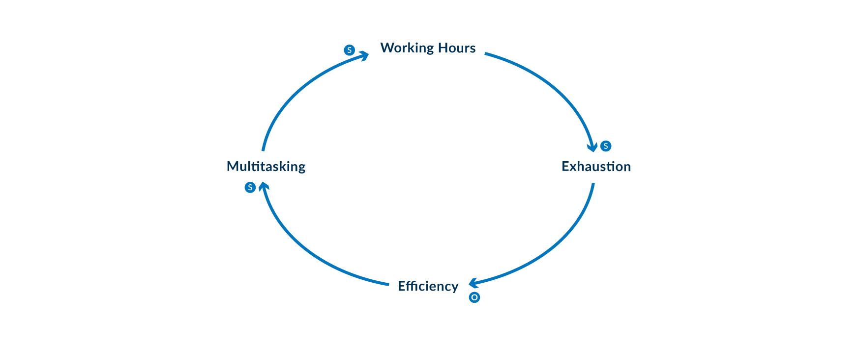

This loop explains how the multitasking that the employees experience increases their workload to the point of exhaustion, thus creating inefficiencies within the organization.

**Green Loop- Organization Efficiency (Balancing)**

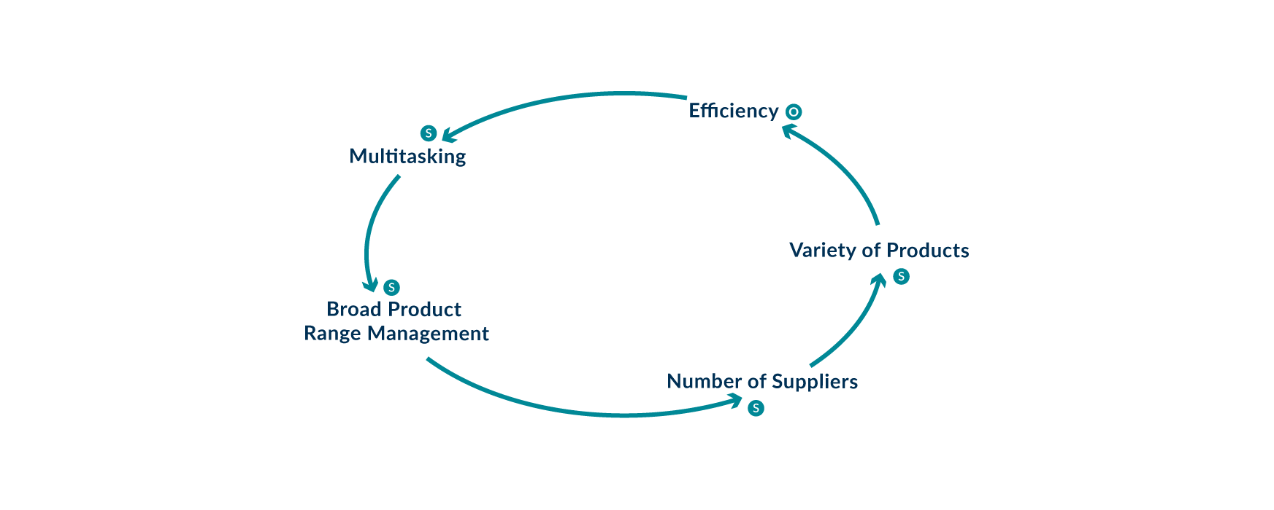

This loop explains how the wide variety of suppliers and products that the company has, creates inefficiencies in the organization, as employees are expected to multi task in order to keep production afloat.

**Red Loop-Organizational Culture/Performance (Reinforcing)**

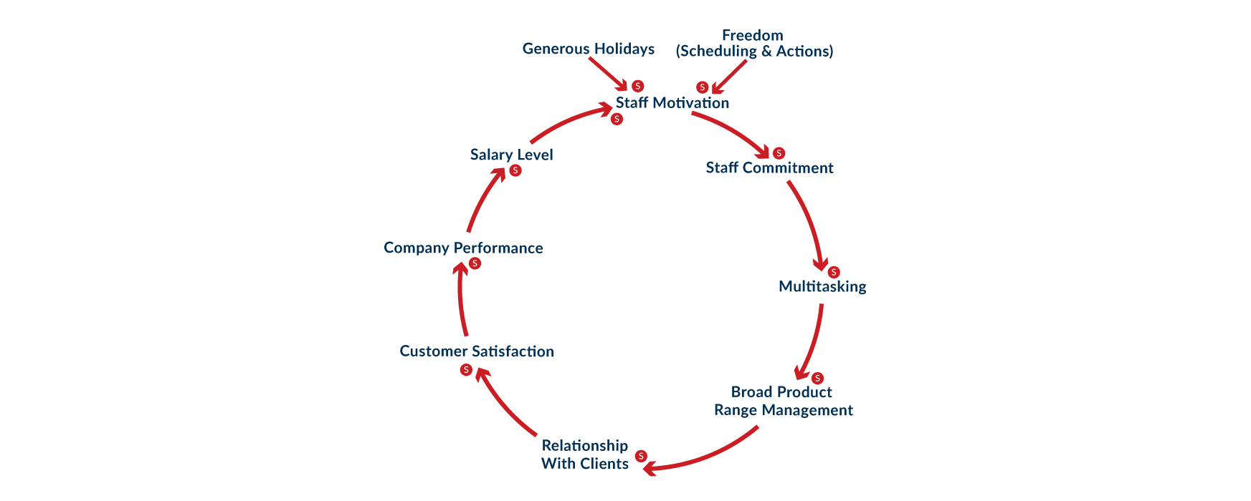

This loop explains how generous holidays and employee freedom greatly increases staff commitment and drives company performance.

**Yellow Loop- Product (Balancing)**

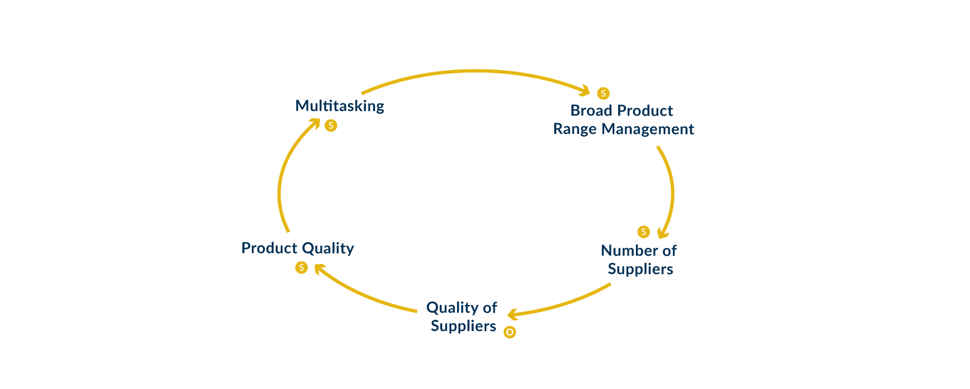

This loop explains how the quality of the product and suppliers actually are lessened as the amount of suppliers that are used increases.

**UE Design Systems Model (Balancing)**

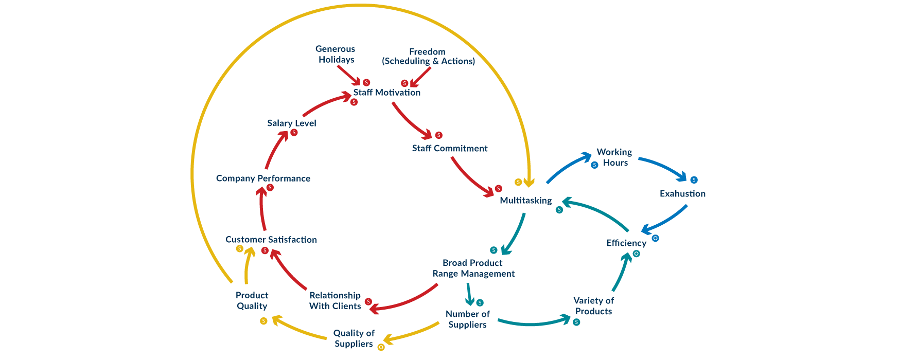

This system of loops shows the relations that all of the loops have with one another. It’s clear that multitasking within the organization has an effect on everything from product quality to employee exhaustion. As multitasking increases product quality falls, and exhaustion in the workforce increases.

**Recommendations:**

To address concerns of overworked employees, communication standards and better respond to the changes of the consumer, there are five changes that are recommended to take place in three phases. The phased implementation is recommended with the intention to mitigate culture shock within the organization.

Phase 1

1. Hiring of a new manager for the Hong Kong branch. This position would be created in order to relieve managerial work for staff allowing them to work and not manage. Another focus of this position would be to stay in close contact with New York to keep both branches’ work and vision aligned.
2. Introduction of organization wide launch and utilization of a project management software, that would be used to increase transparency, maximize Efficiency, and increase speed and quality of communication.

Phase 2

1. Hiring of a new sales focused position
2. Consultant brought on to focus on market demographics and needs.

Phase 3

1. New manager for New York allowing Berardi to pull back and focus on bigger picture.

**Conclusion:**

With the proper implementation of these suggested changes, issues with employee workload, organizational communication lapses shall improve and the company will better have the ability to be more responsive to the changes that constantly take place in the fashion industry.